Goals of Software Testing

The main goal of software testing is to find bugs as early as possible and fix bugs and make sure that the software is bug-free.

Important Goals of Software Testing:
- Detecting bugs as soon as feasible in any situation.
- Avoiding errors in a project’s and product’s final versions.
- Inspect to see whether the customer requirements criterion has been satisfied.
- Last but not least, the primary purpose of testing is to gauge the project and product level of quality.
The goals of software testing may be classified into three major categories as follows:
- Immediate Goals
- Long-term Goals
- Post-Implementation Goals
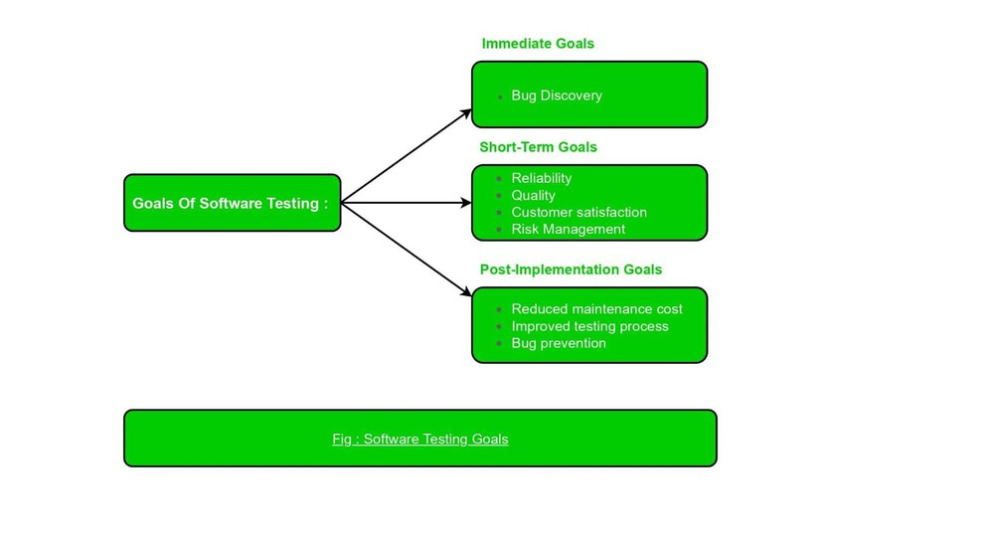
1. Immediate Goals: These objectives are the direct outcomes of testing. These objectives may be set at any time during the SDLC process. Some of these are covered in detail below:
- Bug Discovery: This is the immediate goal of software testing to find errors at any stage of software development. The number of bugs is discovered in the early stage of testing. The primary purpose of software testing is to detect flaws at any step of the development process. The higher the number of issues detected at an early stage, the higher the software testing success rate.
- Bug Prevention: This is the immediate action of bug discovery, that occurs as a result of bug discovery. Everyone in the software development team learns how to code from the behavior and analysis of issues detected, ensuring that bugs are not duplicated in subsequent phases or future projects.
2. Long-Term Goals: These objectives have an impact on product quality in the long run after one cycle of the SDLC is completed. Some of these are covered in detail below:
- Quality: This goal enhances the quality of the software product. Because software is also a product, the user’s priority is its quality. Superior quality is ensured by thorough testing. Correctness, integrity, efficiency, and reliability are all aspects that influence quality. To attain quality, you must achieve all of the above-mentioned quality characteristics.
- Customer Satisfaction: This goal verifies the customer’s satisfaction with a developed software product. The primary purpose of software testing, from the user’s standpoint, is customer satisfaction. Testing should be extensive and thorough if we want the client and customer to be happy with the software product.
- Reliability: It is a matter of confidence that the software will not fail. In short, reliability means gaining the confidence of the customers by providing them with a quality product.
- Risk Management: Risk is the probability of occurrence of uncertain events in the organization and the potential loss that could result in negative consequences. Risk management must be done to reduce the failure of the product and to manage risk in different situations.
3. Post-Implemented Goals: After the product is released, these objectives become critical. Some of these are covered in detail below:
- Reduce Maintenance Cost: Post-released errors are costlier to fix and difficult to identify. Because effective software does not wear out, the maintenance cost of any software product is not the same as the physical cost. The failure of a software product due to faults is the only expense of maintenance. Because they are difficult to discover, post-release mistakes always cost more to rectify. As a result, if testing is done thoroughly and effectively, the risk of failure is lowered, and maintenance costs are reduced as a result.
- Improved Software Testing Process: These goals improve the testing process for future use or software projects. These goals are known as post-implementation goals. A project’s testing procedure may not be completely successful, and there may be room for improvement. As a result, the bug history and post-implementation results can be evaluated to identify stumbling blocks in the current testing process that can be avoided in future projects.
Conclusion: As a way to wrap up, I’d want to emphasize that a tester should be more than simply a tester because the success of a project depends on the tester’s knowledge, insight, communication, confidence, and efforts. Testers should thus comprehend the wider picture in terms of a product’s quality rather than concentrating just on discovering flaws.

Difference between Bug, Defect, Error, Fault & Failure
In this section, we are going to discuss the difference between the Bug, Defect, Error, Fault & Failure as we understood that all the terms are used whenever the system or an application act abnormally.
Sometimes we call it an error and sometimes a bug or a defect and so on. In software testing, many of the new test engineers have confusion in using these terminologies.
Generally, we used these terms in the Software Development Life Cycle (SDLC) based on the phases. But there is a conflict in the usage of these terms.
In other words, we can say that in the era of software testing, the terms bugs, defects, error, fault, and failure come across every second of the day.
PauseNext
Unmute
Current TimeÂ 1:50
/
DurationÂ 18:10
Loaded: 15.78%
Â
Fullscreen
But for a beginner or the inexperienced in this field, all these terminologies may seem synonyms. It became essential to understand each of these terms independently if the software doesn't work as expected.

What is a bug?
In software testing, a bug is the informal name of defects, which means that software or application is not working as per the requirement. When we have some coding error, it leads a program to its breakdown, which is known as a bug. The test engineers use the terminology Bug.
If a QA (Quality Analyst) detect a bug, they can reproduce the bug and record it with the help of the bug report template.

What is a Defect?
When the application is not working as per the requirement is knows as defects. It is specified as the aberration from the actual and expected result of the application or software.
In other words, we can say that the bug announced by the programmer and inside the code is called a Defect.

What is Error?
The Problem in code leads to errors, which means that a mistake can occur due to the developer's coding error as the developer misunderstood the requirement or the requirement was not defined correctly. The developers use the term error.
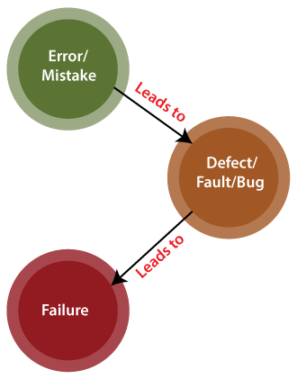

What is Fault?
The fault may occur in software because it has not added the code for fault tolerance, making an application act up.
A fault may happen in a program because of the following reasons:
- Lack of resources
- An invalid step
- Inappropriate data definition

What is Failure?
Many defects lead to the software's failure, which means that a loss specifies a fatal issue in software/ application or in its module, which makes the system unresponsive or broken.
In other words, we can say that if an end-user detects an issue in the product, then that particular issue is called a failure.
Possibilities are there one defect that might lead to one failure or several failures.
For example, in a bank application if the Amount Transfer module is not working for end-users when the end-user tries to transfer money, submit button is not working. Hence, this is a failure.
The flow of the above terminologies are shown in the following image:
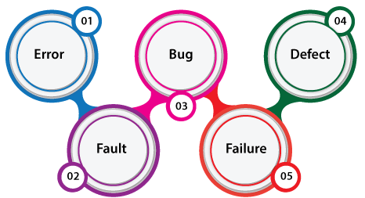

Bug Vs. Defect Vs. Error Vs. Fault Vs. Failure
We have listed some of the vital differences between bug, defect, error, fault, and failure in the below table.
Comparison basis | Bug | Defect | Error | Fault | Failure
Definition | It is an informal name specified to the defect. | The Defect is the difference between the actual outcomes and expected outputs. | An Error is a mistake made in the code; that's why we cannot execute or compile code. | The Fault is a state that causes the software to fail to accomplish its essential function. | If the software has lots of defects, it leads to failure or causes failure.
Raised by | The Test Engineers submit the bug. | The Testers identify the defect. And it was also solved by the developer in the development phase or stage. | The Developers and automation test engineers raise the error. | Human mistakes cause fault. | The failure finds by the manual test engineer through the development cycle.
Different types | Different type of bugs are as follows:  - Logic bugs  - Algorithmic bugs  - Resource bugs | Different type of Defects are as follows:  Based on priority:  - High  - Medium  - Low  And based on the severity:  - Critical  - Major  - Minor  - Trivial | Different type of Error is as below:  - Syntactic Error  - User interface error  - Flow control error  - Error handling error  - Calculation error  - Hardware error  - Testing Error | Different type of Fault are as follows:  - Business Logic Faults  - Functional and Logical Faults  - Faulty GUI  - Performance Faults  - Security Faults  - Software/ hardware fault | -----
Reasons behind | Following are reasons which may cause the bugs:  Missing coding  Wrong coding  Extra coding | The below reason leads to the defects:  Giving incorrect and wrong inputs.  Dilemmas and errors in the outside behavior and inside structure and design.  An error in coding or logic affects the software and causes it to breakdown or the failure. | The reasons for having an error are as follows:  Errors in the code.  The Mistake of some values.  If a developer is unable to compile or run a program successfully.  Confusions and issues in programming.  Invalid login, loop, and syntax.  Inconsistency between actual and expected outcomes.  Blunders in design or requirement actions.  Misperception in understanding the requirements of the application. | The reasons behind the fault are as follows:  A Fault may occur by an improper step in the initial stage, process, or data definition.  Inconsistency or issue in the program.  An irregularity or loophole in the software that leads the software to perform improperly. | Following are some of the most important reasons behind the failure:  Environmental condition  System usage  Users  Human error
Way to prevent the reasons | Following are the way to stop the bugs:  Test-driven development.  Offer programming language support.  Adjusting, advanced, and operative development procedures.  Evaluating the code systematically. | With the help of the following, we can prevent the Defects: Implementing several innovative programming methods.  Use of primary and correct software development techniques.  Peer review  It is executing consistent code reviews to evaluate its quality and correctness. | Below are ways to prevent the Errors:  Enhance the software quality with system review and programming.  Detect the issues and prepare a suitable mitigation plan.  Validate the fixes and verify their quality and precision. | The fault can be prevented with the help of the following:  Peer review.  Assess the functional necessities of the software.  Execute the detailed code analysis.  Verify the correctness of software design and programming. | The way to prevent failure are as follows:  Confirm re-testing.  Review the requirements and revisit the specifications.  Implement current protective techniques.  Categorize and evaluate errors and issues.

Conclusion
After seeing all the significant differences between bug, defect, error, fault, and failure, we can say that the several issues and inconsistencies found throughout software are linked and dependent on each other.
All the above terminology affects and change different parts of the software and differ from one another massively. However, all these differences between bug, defect, errors, faults, and failures slow down the software's excellence and performance.

Test Case
The test case is defined as a group of conditions under which a tester determines whether a software application is working as per the customer's requirements or not. Test case designing includes preconditions, case name, input conditions, and expected result. A test case is a first level action and derived from test scenarios.
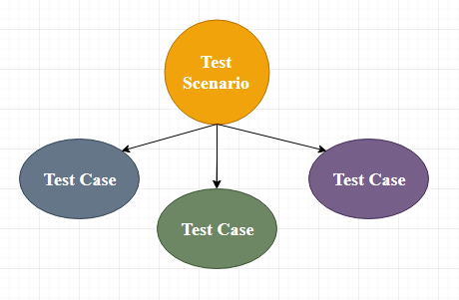
It is an in-details document that contains all possible inputs (positive as well as negative) and the navigation steps, which are used for the test execution process. Writing of test cases is a one-time attempt that can be used in the future at the time of regression testing.
Test case gives detailed information about testing strategy, testing process, preconditions, and expected output. These are executed during the testing process to check whether the software application is performing the task for that it was developed or not.
Test case helps the tester in defect reporting by linking defect with test case ID. Detailed test case documentation works as a full proof guard for the testing team because if developer missed something, then it can be caught during execution of these full-proof test cases.
To write the test case, we must have the requirements to derive the inputs, and the test scenarios must be written so that we do not miss out on any features for testing. Then we should have the test case template to maintain the uniformity, or every test engineer follows the same approach to prepare the test document.
Generally, we will write the test case whenever the developer is busy in writing the code.

When do we write a test case?
We will write the test case when we get the following:
- When the customer gives the business needs then, the developer starts developing and says that they need 3.5 months to build this product.
- And In the meantime, the testing team will start writing the test cases.
- Once it is done, it will send it to the Test Lead for the review process.
- And when the developers finish developing the product, it is handed over to the testing team.
- The test engineers never look at the requirement while testing the product document because testing is constant and does not depends on the mood of the person rather than the quality of the test engineer.

Note: When writing the test case, the actual result should never be written as the product is still being in the development process. That?s why the actual result should be written only after the execution of the test cases.

Why we write the test cases?
We will write the test for the following reasons:
- To require consistency in the test case execution
- To make sure a better test coverage
- It depends on the process rather than on a person
- To avoid training for every new test engineer on the product
To require consistency in the test case execution: we will see the test case and start testing the application.
To make sure a better test coverage: for this, we should cover all possible scenarios and document it, so that we need not remember all the scenarios again and again.
It depends on the process rather than on a person: A test engineer has tested an application during the first release, second release, and left the company at the time of third release. As the test engineer understood a module and tested the application thoroughly by deriving many values. If the person is not there for the third release, it becomes difficult for the new person. Hence all the derived values are documented so that it can be used in the future.
To avoid giving training for every new test engineer on the product: When the test engineer leaves, he/she leaves with a lot of knowledge and scenarios. Those scenarios should be documented so that the new test engineer can test with the given scenarios and also can write the new scenarios.

Note: when the developers are developing the first product for the First release, the test engineer writes the test cases. And in the second release, when the new features are added, the test engineer writes the test cases for that also, and in the next release, when the elements are modified, the test engineer will change the test cases or writes the new test cases as well.

Test case template
The primary purpose of writing a test case is to achieve the efficiency of the application.
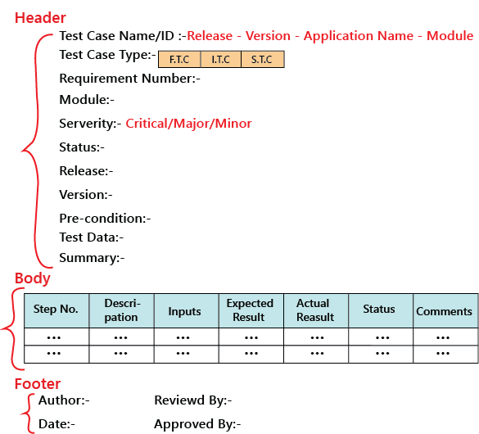
As we know, the actual result is written after the test case execution, and most of the time, it would be same as the expected result. But if the test step will fail, it will be different. So, the actual result field can be skipped, and in the Comments section, we can write about the bugs.
And also, the Input field can be removed, and this information can be added to the Description field.
The above template we discuss above is not the standard one because it can be different for each company and also with each application, which is based on the test engineer and the test lead. But, for testing one application, all the test engineers should follow a usual template, which is formulated.
The test case should be written in simple language so that a new test engineer can also understand and execute the same.
In the above sample template, the header contains the following:
Step number
It is also essential because if step number 20 is failing, we can document the bug report and hence prioritize working and also decide if it’s a critical bug.
Test case type
It can be functional, integration or system test cases or positive or negative or positive and negative test cases.
Release
One release can contain many versions of the release.
Pre-condition
These are the necessary conditions that need to be satisfied by every test engineer before starting the test execution process. Or it is the data configuration or the data setup that needs to be created for the testing.
For example: In an application, we are writing test cases to add users, edit users, and delete users. The per-condition will be seen if user A is added before editing it and removing it.
Test data
These are the values or the input we need to create as per the per-condition.
For example, Username, Password, and account number of the users.
The test lead may be given the test data like username or password to test the application, or the test engineer may themself generate the username and password.
Severity
The severity can be major, minor, and critical, the severity in the test case talks about the importance of that particular test cases. All the text execution process always depends on the severity of the test cases.
We can choose the severity based on the module. There are many features include in a module, even if one element is critical, we claim that test case to be critical. It depends on the functions for which we are writing the test case.
For example, we will take the Gmail application and let us see the severity based on the modules:
Modules | Severity
Login | Critical
Help | Minor
Compose mail | Critical
Setting | Minor
Inbox | Critical
Sent items | Major
Logout | Critical
And for the banking application, the severity could be as follows:
Modules | Severity
Amount transfer | critical
Feedback | minor
Brief description
The test engineer has written a test case for a particular feature. If he/she comes and reads the test cases for the moment, he/she will not know for what feature has written it. So, the brief description will help them in which feature test case is written.

Example of a test case template
Here, we are writing a test case for the ICICI application’s Login module:
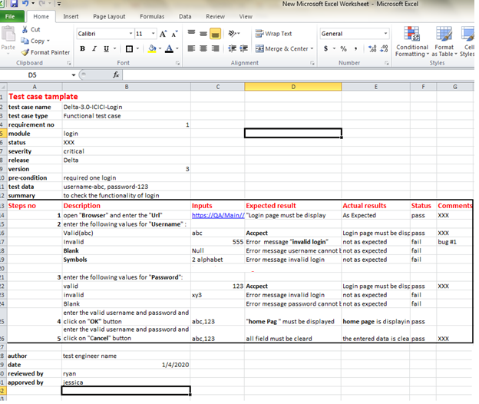

Types of test cases
We have a different kind of test cases, which are as follows:
- Function test cases
- Integration test cases
- System test cases

The functional test cases
Firstly, we check for which field we will write test cases and then describe accordingly.
In functional testing or if the application is data-driven, we require the input column else; it is a bit time-consuming.
Rules to write functional test cases:
- In the expected results column, try to use should be or must be.
- Highlight the Object names.
- We have to describe only those steps which we required the most; otherwise, we do not need to define all the steps.
- To reduce the excess execution time, we will write steps correctly.
- Write a generic test case; do not try to hard code it.
Let say it is the amount transfer module, so we are writing the functional test cases for it and then also specifies that it is not a login feature.
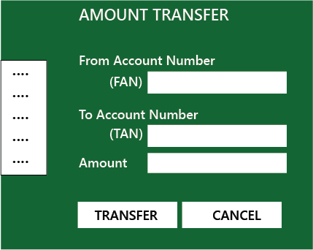
The functional test case for amount transfer module is in the below Excel file:
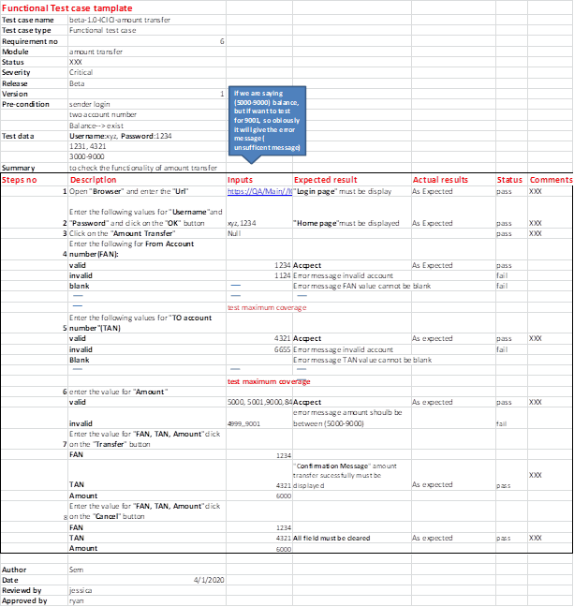

Integration test case
In this, we should not write something which we already covered in the functional test cases, and something we have written in the integration test case should not be written in the system test case again.
Rules to write integration test cases
- Firstly, understand the product
- Identify the possible scenarios
- Write the test case based on the priority
When the test engineer writing the test cases, they may need to consider the following aspects:
If the test cases are in details:
- They will try to achieve maximum test coverage.
- All test case values or scenarios are correctly described.
- They will try to think about the execution point of view.
- The template which is used to write the test case must be unique.

Note: when we involve fewer numbers of steps or coverage is more, it should be the best test case, and when these test cases are given to anyone, they will understand easily.

System test cases
We will write the system test cases for the end-to-end business flows. And we have the entire modules ready to write the system test cases.

The process to write test cases
The method of writing a test case can be completed into the following steps, which are as below:
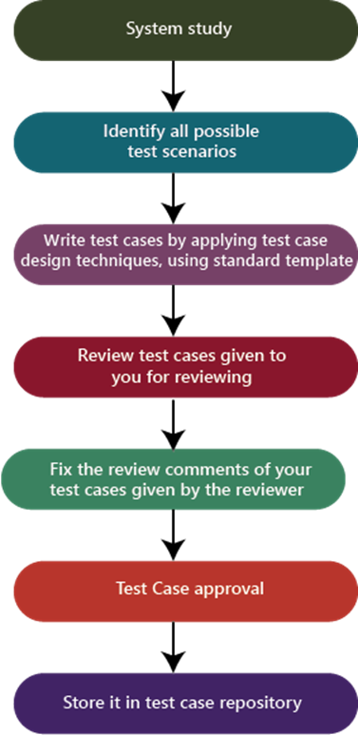
System study
In this, we will understand the application by looking at the requirements or the SRS, which is given by the customer.
Identify all scenarios:
- When the product is launched, what are the possible ways the end-user may use the software to identify all the possible ways.
- I have documented all possible scenarios in a document, which is called test design/high-level design.
- The test design is a record having all the possible scenarios.
Write test cases
Convert all the identified scenarios to test claims and group the scenarios related to their features, prioritize the module, and write test cases by applying test case design techniques and use the standard test case template, which means that the one which is decided for the project.
Review the test cases
Review the test case by giving it to the head of the team and, after that, fix the review feedback given by the reviewer.
Test case approval
After fixing the test case based on the feedback, send it again for the approval.

When to Stop Testing (Exit Criteria in Software Testing)

Overview
Software Testing is a much-needed part of every software development life cycle. Without testing, you can’t deploy any software into the market. But do you know, what the two most important steps matter in the Software testing life cycle? - when to start testing(Entry criteria) and when to stop testing(Exit criteria)?
In entry criteria, we start testing as early as possible to identify bugs in the development cycle itself so it will be easy to fix them. In exit criteria, there are some metrics based on which we decide when to stop testing or how much testing is enough.

Introduction
Testing is an important aspect of software development as without testing, we can't think about deploying our application into production. However, when to stop testing is also quite challenging. On the one hand, too little testing can leave software vulnerable to bugs, errors, and security vulnerabilities, while on the other hand, excessive testing can be costly and delay the release of the software.
In this article, we will see when to stop or what are the exit criteria in software testing in detail. Whether you're a software developer, tester, or manager, this article will provide valuable insights to help you optimize your `testing efforts and improve the quality of your software.

Explore and unlock therecipe to transform your career
3700+
Placed at Google Amazon and other top tech companies
93.5% Placement Rate
21.6LPA Average salary of learners
126% average salary hike
₹900CR Salary created for Scaler graduates in last 4 years
Discover & connect with Alumni who have walked the same path as you

Krishna Chaitanya
Software Engineer III
Pre-Scaler
Sigmoid
Post-Scaler

200% Hike
I am a tech enthusiast now, but that was not always the case. I come from a non-tech background and used to be very unfamilia... Read Full Review

Sudhanshu Gera
Software Engineer III
Pre-Scaler
Wipro Limited
Post-Scaler

150% Hike
At the beginning, it was not the easiest of tasks to cope up with the classes but I was stern in my intent which helped me la... Read Full Review

Ankit Pangasa
Senior Software Engineer
Pre-Scaler
Adobe
Post-Scaler

200% Hike
Their course structure is impeccable and has truly helped me widen the horizons of my knowledge. They have truly established ... Read Full Review

Vikas Tiwari
Backend Developer
Pre-Scaler
Innefu
Post-Scaler

180% Hike
All thanks to Scaler Academy for providing such amazing learning resources which helped me to become a better engineer.... Read Full Review

Abinay Bingumalla
Full Stack
Pre-Scaler
Reliance Infocomm Limited
Post-Scaler

112% Hike
With Scaler, I became a lot more disciplined and focused. Without their support, maybe it would have taken me a few more year... Read Full Review

Saliq Saifi
Senior Software Engineer
Pre-Scaler
Mahindra Comviva
Post-Scaler

400% Hike
The best career decision I ever made was to join Scaler by InterviewBit. I was preparing myself but couldn't get any good opp... Read Full Review
Talk to Counsellor
Read All Reviews

When is it Enough Testing?
Deciding how much testing is enough is a very crucial task as you can’t predict enough parts from a testing point of view. As long as continuous development is going on, testing will be there, But still, there are some factors to decide whether enough testing has been done or not. Some of these are time and budget constraints, test coverage, quality metrics, user feedback, etc.

Stopping when all Defects are Found: Is it Possible?
The main aim of testing is not to find as many defects in the software but to prove that the software does work even with intentions of breaking it. No one can assure you that the software is completely 100% bug-free or the testing has been fully completed.
Not every software testing is easy, some are so complex that they may have unlimited bugs. You can't detect every bug hence it’s impractical to test it.
The fact is testing is an endless process and it continues till the software exists. It is not impossible to find all defects in software but definitely, it is not the decisive factor to stop testing.
Explore free courses by our top instructorsView All

TARUN LUTHRA
Java Course - Mastering the Fundamentals
76k+ enrolled

RAHUL JANGHU
Python Course for Beginners With Certification: Mastering the Essentials
65k+ enrolled

PRATEEK NARANG
C++ Course: Learn the Essentials
39k+ enrolled
35,262+ learners have attended these Courses.

Decision to Stop Testing: Exit Criteria
Here are some points based on which you can decide when to stop testing:
- When test cases are completed with a maximum pass percentage
- When the defect rate drop from the calculated level
- When the budget came to its end
- When the release deadlines have been reached.

What are the Completion or Exit Criteria?
The exit criteria are nothing but the conditions or criteria based on which the test cycle ends. All the Coverages (Pass, Defect) and test completion are factors that decide the exit criteria.
Here are some points :
1) Defect closure rate: This completion criterion is based on the rate at which defects are being identified and fixed.
2) Test case coverage: Completion criteria based on test case coverage means that a certain percentage of the total test cases should be executed and passed successfully before testing can be considered complete.
3) Time-based criteria: When testing is limited to a specific period, such as a certain number of days, weeks, or months, time-based criteria can be used to determine when testing must be stopped.

What should be present in the Exit Criteria?
The exit criteria is usually decided at the beginning of the test cycle i.e. Test planning stage and it also depends on the project and requirements. Below are some key points you can decide when to stop testing as per your project needs.
- Time and budget constraints
- Stakeholder approval
- Risk-based analysis./
- All testing-related documents and deliverables have been created, reviewed, and shared with the appropriate stakeholders.
- All the high-priority bugs must be resolved and the bug rate level comes at a low level.

Conclusion
As we all know, "Testing is a never-ending process" and it may happen that just now you finished with the testing and suddenly found a new bug. It’s just like the cycle will continue. But how would we know when to stop testing at last?
Here are some checklists below, if you get most of your answers in "yes", you may stop testing, and if not, you may find out what exactly is missing before the bug hits production.

Verification and Validation Testing
In this section, we will learn about verification and validation testing and their major differences.

Verification testing
Verification testing includes different activities such as business requirements, system requirements, design review, and code walkthrough while developing a product.
It is also known as static testing, where we are ensuring that "we are developing the right product or not". And it also checks that the developed application fulfilling all the requirements given by the client.
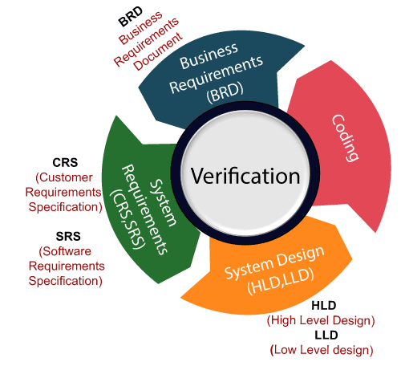

Validation testing
Validation testing is testing where tester performed functional and non-functional testing. Here functional testing includes Unit Testing (UT), Integration Testing (IT) and System Testing (ST), and non-functional testing includes User acceptance testing (UAT).
PauseNext
Unmute
Current TimeÂ 0:00
/
DurationÂ 18:10
Â
Fullscreen
Validation testing is also known as dynamic testing, where we are ensuring that "we have developed the product right." And it also checks that the software meets the business needs of the client.
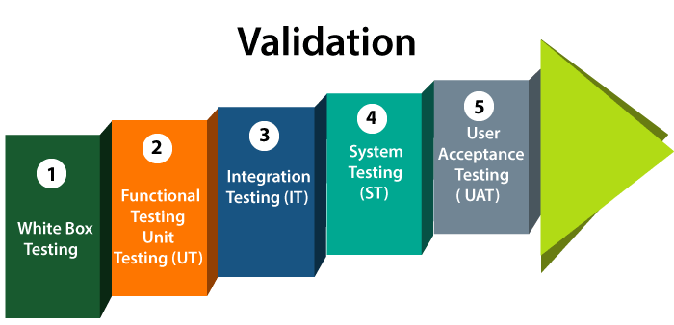

Note: Verification and Validation process are done under the V model of the software development life cycle.

Difference between verification and validation testing
Verification | Validation
We check whether we are developing the right product or not. | We check whether the developed product is right.
Verification is also known as static testing. | Validation is also known as dynamic testing.
Verification includes different methods like Inspections, Reviews, and Walkthroughs. | Validation includes testing like functional testing, system testing, integration, and User acceptance testing.
It is a process of checking the work-products (not the final product) of a development cycle to decide whether the product meets the specified requirements. | It is a process of checking the software during or at the end of the development cycle to decide whether the software follow the specified business requirements.
Quality assurance comes under verification testing. | Quality control comes under validation testing.
The execution of code does not happen in the verification testing. | In validation testing, the execution of code happens.
In verification testing, we can find the bugs early in the development phase of the product. | In the validation testing, we can find those bugs, which are not caught in the verification process.
Verification testing is executed by the Quality assurance team to make sure that the product is developed according to customers' requirements. | Validation testing is executed by the testing team to test the application.
Verification is done before the validation testing. | After verification testing, validation testing takes place.
In this type of testing, we can verify that the inputs follow the outputs or not. | In this type of testing, we can validate that the user accepts the product or not.

Quality Assurance vs Quality Control

Quality Assurance
Software quality assurance is (also known as QA) a sequence of tasks to prevent defects and ensure that the techniques, methods, approaches, and processes are designed for a specific application must be implemented correctly. This is an ongoing process within the development of a software system.
The development of units of an application is checked under the quality assurance specifications in the sequence of their development.
Quality assurance test ensures the development of high-quality software because of its main focus on the high-quality processes, good quality management system and periodic conformance audit during the development of software. It is a managerial tool includes planned and systematic activities and documentation to prevent problems related to quality.
The responsibility of quality assurance is not of any specific team, but it is a responsibility of each member of the development team.
- Quality assurance prevents defects.
- Quality assurance is process oriented.
- Quality assurance is proactive in a process and preventive in nature.
- Quality assurance is a managerial tool.
- Each developer is responsible for quality assurance.

Quality Control
Quality Control also known as QC is a sequence of tasks to ensure the quality of software by identifying defects and correction of defects in the developed software. It is a reactive process, and the main purpose of this process is to correct all types of defects before releasing the software. The process is done by eliminating sources of problems (which cause to low the quality) through the corrective tools so that software can meet customer's requirements and high quality.
The responsibility of quality control is of a specific team which is known as a testing team that tests the defects of software by validation and corrective tools.
- Quality Control provides identification of defects.
- Quality Control is product oriented.
- Quality Control is a corrective tool.
- Testing team is responsible for Quality control.
- Quality Control is a reactive process.

Difference between Quality Assurance and Quality Control
Points | Quality Assurance | Quality Control
Definition | QA is a group of activities which ensures that the quality of processes which is used during the development of the software always be maintained. | QC is a group of activities to detect the defects in the developed software.
Focus | The focus of QA is to prevent defects in the developing paying attention to processes. | The focus of QC is to identify defects in the developed software by paying attention to testing processes.
How | Establishment of the high-quality management system and periodic audits for conformance of the operations of the developing software. | Detecting and eliminating the quality problem elements by using testing techniques and tools in the developed software.
What | QA ensures prevention of quality problem elements b y using systematic activities including documentation. | QC ensures identification and elimination of defects by using processes and techniques to achieve and maintain high quality of the software.
Orientation | QA is process oriented. | QC is product oriented.
Type of process | QA is a proactive process. It concerns to improve development so; defects do not arise in the testing period. | QC is a reactive process because it concerns to identify defects after the development of product and before its release.
Responsibility | Each and every member of the development team is responsible for QA | Only the specific testing team is responsible for QC
Example | Verification is the example of QA | Validation is the example of QC

Static Testing vs. Dynamic Testing

Static Testing
Static testing is testing, which checks the application without executing the code. It is a verification process. Some of the essential activities are done under static testing such as business requirement review, design review, code walkthroughs, and the test documentation review.
Static testing is performed in the white box testing phase, where the programmer checks every line of the code before handling over to the Test Engineer.
Static testing can be done manually or with the help of tools to improve the quality of the application by finding the error at the early stage of development; that why it is also called the verification process.
The documents review, high and low-level design review, code walkthrough take place in the verification process.

Dynamic Testing
Dynamic testing is testing, which is done when the code is executed at the run time environment. It is a validation process where functional testing [unit, integration, and system testing] and non-functional testing [user acceptance testing] are performed.
We will perform the dynamic testing to check whether the application or software is working fine during and after the installation of the application without any error.

Difference between Static testing and Dynamic Testing
Static testing | Dynamic testing
In static testing, we will check the code or the application without executing the code. | In dynamic testing, we will check the code/application by executing the code.
Static testing includes activities like code Review, Walkthrough, etc. | Dynamic testing includes activities like functional and non-functional testing such as UT (usability testing), IT (integration testing), ST (System testing) & UAT (user acceptance testing).
Static testing is a Verification Process. | Dynamic testing is a Validation Process.
Static testing is used to prevent defects. | Dynamic testing is used to find and fix the defects.
Static testing is a more cost-effective process. | Dynamic testing is a less cost-effective process.
This type of testing can be performed before the compilation of code. | Dynamic testing can be done only after the executables are prepared.
Under static testing, we can perform the statement coverage testing and structural testing. | Equivalence Partitioning and Boundary Value Analysis technique are performed under dynamic testing.
It involves the checklist and process which has been followed by the test engineer. | This type of testing required the test case for the execution of the code.

White Box Testing
The box testing approach of software testing consists of black box testing and white box testing. We are discussing here white box testing which also known as glass box is testing, structural testing, clear box testing, open box testing and transparent box testing. It tests internal coding and infrastructure of a software focus on checking of predefined inputs against expected and desired outputs. It is based on inner workings of an application and revolves around internal structure testing. In this type of testing programming skills are required to design test cases. The primary goal of white box testing is to focus on the flow of inputs and outputs through the software and strengthening the security of the software.
The term 'white box' is used because of the internal perspective of the system. The clear box or white box or transparent box name denote the ability to see through the software's outer shell into its inner workings.
Developers do white box testing. In this, the developer will test every line of the code of the program. The developers perform the White-box testing and then send the application or the software to the testing team, where they will perform the black box testing and verify the application along with the requirements and identify the bugs and sends it to the developer.
The developer fixes the bugs and does one round of white box testing and sends it to the testing team. Here, fixing the bugs implies that the bug is deleted, and the particular feature is working fine on the application.
Here, the test engineers will not include in fixing the defects for the following reasons:
- Fixing the bug might interrupt the other features. Therefore, the test engineer should always find the bugs, and developers should still be doing the bug fixes.
- If the test engineers spend most of the time fixing the defects, then they may be unable to find the other bugs in the application.
The white box testing contains various tests, which are as follows:
- Path testing
- Loop testing
- Condition testing
- Testing based on the memory perspective
- Test performance of the program

Path testing
In the path testing, we will write the flow graphs and test all independent paths. Here writing the flow graph implies that flow graphs are representing the flow of the program and also show how every program is added with one another as we can see in the below image:
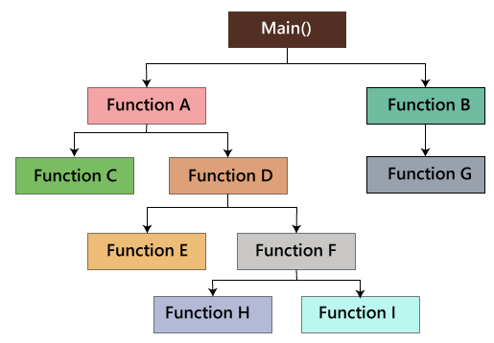
And test all the independent paths implies that suppose a path from main() to function G, first set the parameters and test if the program is correct in that particular path, and in the same way test all other paths and fix the bugs.

Loop testing
In the loop testing, we will test the loops such as while, for, and do-while, etc. and also check for ending condition if working correctly and if the size of the conditions is enough.
For example: we have one program where the developers have given about 50,000 loops.
- {
- while(50,000)
- ……
- ……
- }
We cannot test this program manually for all the 50,000 loops cycle. So we write a small program that helps for all 50,000 cycles, as we can see in the below program, that test P is written in the similar language as the source code program, and this is known as a Unit test. And it is written by the developers only.
- Test P
- {
- ……
- …… }
As we can see in the below image that, we have various requirements such as 1, 2, 3, 4. And then, the developer writes the programs such as program 1,2,3,4 for the parallel conditions. Here the application contains the 100s line of codes.
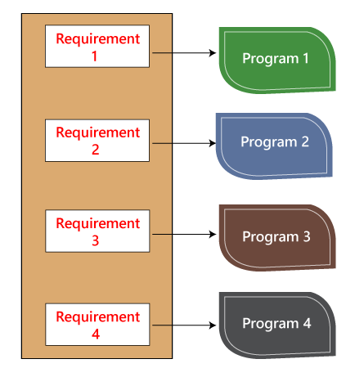
The developer will do the white box testing, and they will test all the five programs line by line of code to find the bug. If they found any bug in any of the programs, they will correct it. And they again have to test the system then this process contains lots of time and effort and slows down the product release time.
Now, suppose we have another case, where the clients want to modify the requirements, then the developer will do the required changes and test all four program again, which take lots of time and efforts.
These issues can be resolved in the following ways:
In this, we will write test for a similar program where the developer writes these test code in the related language as the source code. Then they execute these test code, which is also known as unit test programs. These test programs linked to the main program and implemented as programs.
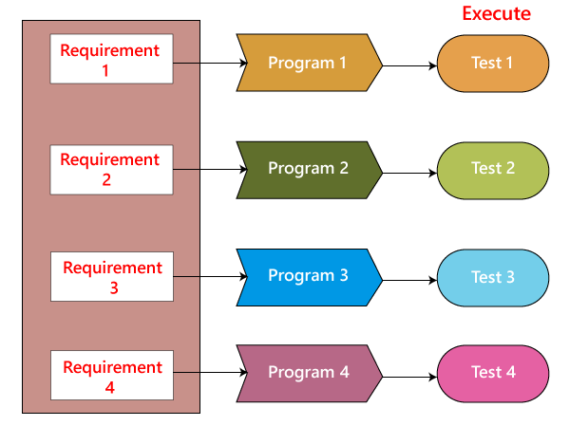
Therefore, if there is any requirement of modification or bug in the code, then the developer makes the adjustment both in the main program and the test program and then executes the test program.

Condition testing
In this, we will test all logical conditions for both true and false values; that is, we will verify for both if and else condition.
For example:
- if(condition) - true
- {
- …..
- ……
- ……
- }
- else - false
- {
- …..
- ……
- ……
- }
The above program will work fine for both the conditions, which means that if the condition is accurate, and then else should be false and conversely.

Testing based on the memory (size) perspective
The size of the code is increasing for the following reasons:
- The reuse of code is not there: let us take one example, where we have four programs of the same application, and the first ten lines of the program are similar. We can write these ten lines as a discrete function, and it should be accessible by the above four programs as well. And also, if any bug is there, we can modify the line of code in the function rather than the entire code.
- The developers use the logic that might be modified. If one programmer writes code and the file size is up to 250kb, then another programmer could write a similar code using the different logic, and the file size is up to 100kb.
- The developer declares so many functions and variables that might never be used in any portion of the code. Therefore, the size of the program will increase.
For example,
- Int a=15;
- Int b=20;
- String S= "Welcome";
- ….
- …..
- …..
- ….
- …..
- Int p=b;
- Create user()
- {
- ……
- ……
- ….. 200's line of code
- }
In the above code, we can see that the integer a has never been called anywhere in the program, and also the function Create user has never been called anywhere in the code. Therefore, it leads us to memory consumption.
We cannot remember this type of mistake manually by verifying the code because of the large code. So, we have a built-in tool, which helps us to test the needless variables and functions. And, here we have the tool called Rational purify.
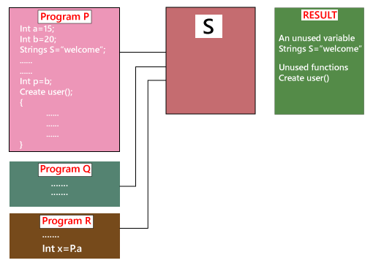
Suppose we have three programs such as Program P, Q, and R, which provides the input to S. And S goes into the programs and verifies the unused variables and then gives the outcome. After that, the developers will click on several results and call or remove the unnecessary function and the variables.
This tool is only used for the C programming language and C++ programming language; for another language, we have other related tools available in the market.
- The developer does not use the available in-built functions; instead they write the full features using their logic. Therefore, it leads us to waste of time and also postpone the product releases.

Test the performance (Speed, response time) of the program
The application could be slow for the following reasons:
- When logic is used.
- For the conditional cases, we will use or & and adequately.
- Switch case, which means we cannot use nested if, instead of using a switch case.
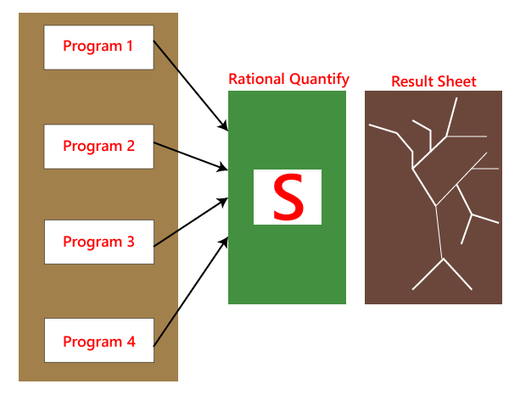
As we know that the developer is performing white box testing, they understand that the code is running slow, or the performance of the program is also getting deliberate. And the developer cannot go manually over the program and verify which line of the code is slowing the program.
To recover with this condition, we have a tool called Rational Quantify, which resolves these kinds of issues automatically. Once the entire code is ready, the rational quantify tool will go through the code and execute it. And we can see the outcome in the result sheet in the form of thick and thin lines.
Here, the thick line specifies which section of code is time-consuming. When we double-click on the thick line, the tool will take us to that line or piece of code automatically, which is also displayed in a different color. We can change that code and again and use this tool. When the order of lines is all thin, we know that the presentation of the program has enhanced. And the developers will perform the white box testing automatically because it saves time rather than performing manually.
Test cases for white box testing are derived from the design phase of the software development lifecycle. Data flow testing, control flow testing, path testing, branch testing, statement and decision coverage all these techniques used by white box testing as a guideline to create an error-free software.
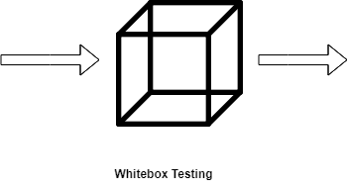
White box testing follows some working steps to make testing manageable and easy to understand what the next task to do. There are some basic steps to perform white box testing.

Generic steps of white box testing
- Design all test scenarios, test cases and prioritize them according to high priority number.
- This step involves the study of code at runtime to examine the resource utilization, not accessed areas of the code, time taken by various methods and operations and so on.
- In this step testing of internal subroutines takes place. Internal subroutines such as nonpublic methods, interfaces are able to handle all types of data appropriately or not.
- This step focuses on testing of control statements like loops and conditional statements to check the efficiency and accuracy for different data inputs.
- In the last step white box testing includes security testing to check all possible security loopholes by looking at how the code handles security.

Reasons for white box testing
- It identifies internal security holes.
- To check the way of input inside the code.
- Check the functionality of conditional loops.
- To test function, object, and statement at an individual level.

Advantages of White box testing
- White box testing optimizes code so hidden errors can be identified.
- Test cases of white box testing can be easily automated.
- This testing is more thorough than other testing approaches as it covers all code paths.
- It can be started in the SDLC phase even without GUI.

Disadvantages of White box testing
- White box testing is too much time consuming when it comes to large-scale programming applications.
- White box testing is much expensive and complex.
- It can lead to production error because it is not detailed by the developers.
- White box testing needs professional programmers who have a detailed knowledge and understanding of programming language and implementation.

Techniques Used in White Box Testing
Data Flow Testing | Data flow testing is a group of testing strategies that examines the control flow of programs in order to explore the sequence of variables according to the sequence of events.
Control Flow Testing | Control flow testing determines the execution order of statements or instructions of the program through a control structure. The control structure of a program is used to develop a test case for the program. In this technique, a particular part of a large program is selected by the tester to set the testing path. Test cases represented by the control graph of the program.
Branch Testing | Branch coverage technique is used to cover all branches of the control flow graph. It covers all the possible outcomes (true and false) of each condition of decision point at least once.
Statement Testing | Statement coverage technique is used to design white box test cases. This technique involves execution of all statements of the source code at least once. It is used to calculate the total number of executed statements in the source code, out of total statements present in the source code.
Decision Testing | This technique reports true and false outcomes of Boolean expressions. Whenever there is a possibility of two or more outcomes from the statements like do while statement, if statement and case statement (Control flow statements), it is considered as decision point because there are two outcomes either true or false.

Difference between white-box testing and black-box testing
Following are the significant differences between white box testing and black box testing:
White-box testing | Black box testing
The developers can perform white box testing. | The test engineers perform the black box testing.
To perform WBT, we should have an understanding of the programming languages. | To perform BBT, there is no need to have an understanding of the programming languages.
In this, we will look into the source code and test the logic of the code. | In this, we will verify the functionality of the application based on the requirement specification.
In this, the developer should know about the internal design of the code. | In this, there is no need to know about the internal design of the code.

Black box testing
Black box testing is a technique of software testing which examines the functionality of software without peering into its internal structure or coding. The primary source of black box testing is a specification of requirements that is stated by the customer.
In this method, tester selects a function and gives input value to examine its functionality, and checks whether the function is giving expected output or not. If the function produces correct output, then it is passed in testing, otherwise failed. The test team reports the result to the development team and then tests the next function. After completing testing of all functions if there are severe problems, then it is given back to the development team for correction.


Generic steps of black box testing
- The black box test is based on the specification of requirements, so it is examined in the beginning.
- In the second step, the tester creates a positive test scenario and an adverse test scenario by selecting valid and invalid input values to check that the software is processing them correctly or incorrectly.
- In the third step, the tester develops various test cases such as decision table, all pairs test, equivalent division, error estimation, cause-effect graph, etc.
- The fourth phase includes the execution of all test cases.
- In the fifth step, the tester compares the expected output against the actual output.
- In the sixth and final step, if there is any flaw in the software, then it is cured and tested again.

Test procedure
The test procedure of black box testing is a kind of process in which the tester has specific knowledge about the software's work, and it develops test cases to check the accuracy of the software's functionality.
It does not require programming knowledge of the software. All test cases are designed by considering the input and output of a particular function.A tester knows about the definite output of a particular input, but not about how the result is arising. There are various techniques used in black box testing for testing like decision table technique, boundary value analysis technique, state transition, All-pair testing, cause-effect graph technique, equivalence partitioning technique, error guessing technique, use case technique and user story technique. All these techniques have been explained in detail within the tutorial.

Test cases
Test cases are created considering the specification of the requirements. These test cases are generally created from working descriptions of the software including requirements, design parameters, and other specifications. For the testing, the test designer selects both positive test scenario by taking valid input values and adverse test scenario by taking invalid input values to determine the correct output. Test cases are mainly designed for functional testing but can also be used for non-functional testing. Test cases are designed by the testing team, there is not any involvement of the development team of software.

Techniques Used in Black Box Testing
Decision Table Technique | Decision Table Technique is a systematic approach where various input combinations and their respective system behavior are captured in a tabular form. It is appropriate for the functions that have a logical relationship between two and more than two inputs.
Boundary Value Technique | Boundary Value Technique is used to test boundary values, boundary values are those that contain the upper and lower limit of a variable. It tests, while entering boundary value whether the software is producing correct output or not.
State Transition Technique | State Transition Technique is used to capture the behavior of the software application when different input values are given to the same function. This applies to those types of applications that provide the specific number of attempts to access the application.
All-pair Testing Technique | All-pair testing Technique is used to test all the possible discrete combinations of values. This combinational method is used for testing the application that uses checkbox input, radio button input, list box, text box, etc.
Cause-Effect Technique | Cause-Effect Technique underlines the relationship between a given result and all the factors affecting the result.It is based on a collection of requirements.
Equivalence Partitioning Technique | Equivalence partitioning is a technique of software testing in which input data divided into partitions of valid and invalid values, and it is mandatory that all partitions must exhibit the same behavior.
Error Guessing Technique | Error guessing is a technique in which there is no specific method for identifying the error. It is based on the experience of the test analyst, where the tester uses the experience to guess the problematic areas of the software.
Use Case Technique | Use case Technique used to identify the test cases from the beginning to the end of the system as per the usage of the system. By using this technique, the test team creates a test scenario that can exercise the entire software based on the functionality of each function from start to end.

